First grade – First term

1. Sets

What is a set
- What is a set?

Suggested activities:
- Create your own set, why is a set?
- Identify 6 sets in your house and explain why they are sets.

Games:
- https://wordwall.net/es/resource/78528970/math/sets-of-objects
- https://wordwall.net/es/resource/7178922/math/number-sets
- https://wordwall.net/es/resource/62246840/shape-sets

2. Greater than, less than, equal to

Symbols:
- https://superstarworksheets.com/wp-content/uploads/2023/10/GreaterThanLessThanChart.pdf

Worksheets:
- https://www.superteacherworksheets.com/counting/more-and-fewer_BBAGT.pdf
- https://www.superteacherworksheets.com/place-value/greaterless-2digit_TWRBD.pdf
- https://www.k5learning.com/free-math-worksheets/first-grade-1/comparing-numbers/more-than-less-than
- https://superstarworksheets.com/math-worksheets/comparing-numbers/comparing-numbers-worksheets/
- https://www.k5learning.com/free-math-worksheets/first-grade-1/comparing-numbers/compare-numbers-0-100

Games:
- https://www.superteacherworksheets.com/place-value/gt-lt-game2-3-digits_GFDIW.pdf
- https://www.starfall.com/h/numbers/greater-less-equals/?sn=math0
- https://www.abcya.com/games/comparing_number_values_jr
- https://wordwall.net/resource/37870946/greater-than-or-less-than
- https://www.education.com/game/less-than-greater-than/

Videos:

3. Word Problems

Worksheets:
- https://www.superteacherworksheets.com/addition/adding-2digit-noregroup_TTWTN.pdf
- https://www.superteacherworksheets.com/addition/adding-columns3_TTZDN.pdf
- https://www.k5learning.com/free-math-worksheets/first-grade-1/word-problems/adding-single-digit-numbers
- https://www.k5learning.com/free-math-worksheets/first-grade-1/word-problems/addition-sums-50
- https://www.k5learning.com/free-math-worksheets/first-grade-1/word-problems/addition-3-addends
- https://www.superteacherworksheets.com/daily-word-problems-a.html
- https://www.k5learning.com/free-math-worksheets/first-grade-1/word-problems/subtraction
- https://www.k5learning.com/free-math-worksheets/first-grade-1/word-problems/subtraction-2-digits

Game:
- Create your own problem and share with your family

Videos:
- https://www.youtube.com/watch?v=C229LUk380Q
- https://www.youtube.com/watch?v=s3jP0vnFSxE

UPAC:
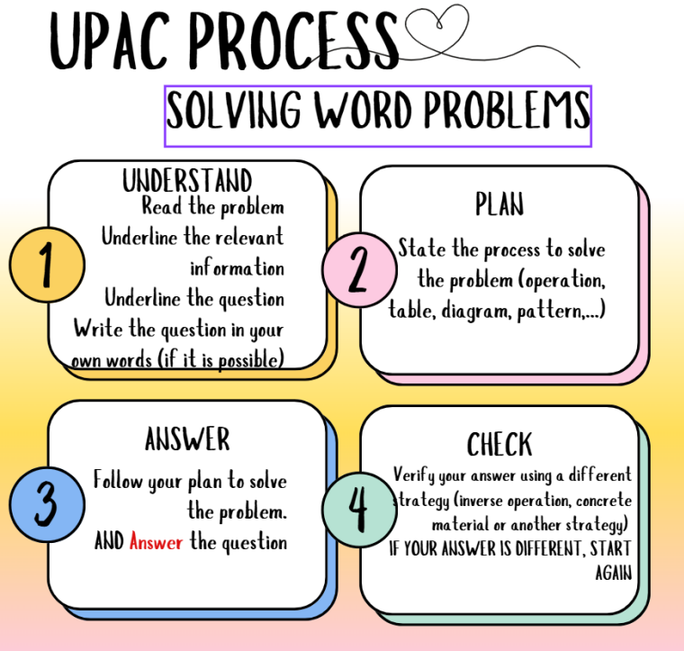
You can use this template to solve problems:
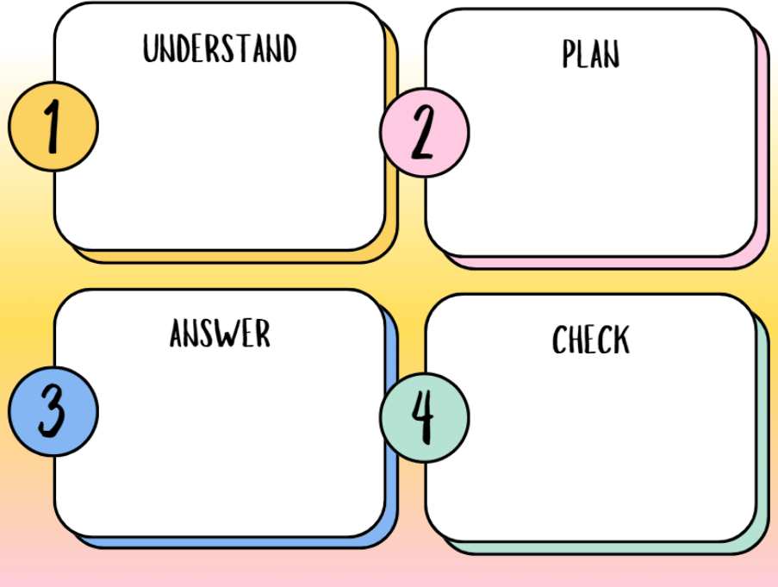

4. Patterns / Patrones

Worksheets:
- https://www.mathworksheets4kids.com/worksheets/1st-grade/patterns/repeating-circle-1.pdf
- https://www.mathworksheets4kids.com/patterns/repeating-cut-paste1.pdf
- https://www.mathworksheets4kids.com/patterns/growing-type1-1.pdf
- https://www.mathworksheets4kids.com/patterns/repeating-growing-mixed1.pdf
- https://www.mathworksheets4kids.com/patterns/size-circle1.pdf
- https://www.mathworksheets4kids.com/patterns/color-easy1.pdf

Video:
- https://www.youtube.com/watch?v=CzFLDtvN_Xk
- https://www.youtube.com/watch?v=Js45cR_7wFE

Games:
- https://www.abcya.com/games/shape_patterns
- https://wordwall.net/resource/34012902/patterns
- https://wordwall.net/resource/35314613/patterns
- https://wordwall.net/resource/27288737/patterns-game
- https://wordwall.net/resource/29534647/colour-patterns
- https://wordwall.net/resource/39037001/numberblocks-patterns

5. Tessellations

What is?
https://www.mathsisfun.com/geometry/tessellation.html

Worksheets:
- https://www.k5learning.com/worksheets/math/grade-4-geometry-tessellations-a.pdf
- https://www.k5learning.com/worksheets/math/grade-4-geometry-tessellations-b.pdf

Video:
https://www.youtube.com/watch?v=7GiKeeWSf4s
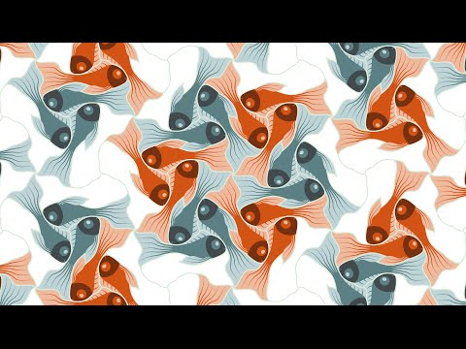

6. How do you write numbers?
https://www.123homeschool4me.com/free-number-works

